World premiere of Pearl of Freedom by Joanna Marsh in memory of Emily Davison to mark the 100th anniversary of the Representation of the People Act

Pearl of Freedom
St John’s Smith Square
Wednesday 31 January | 7:30pm

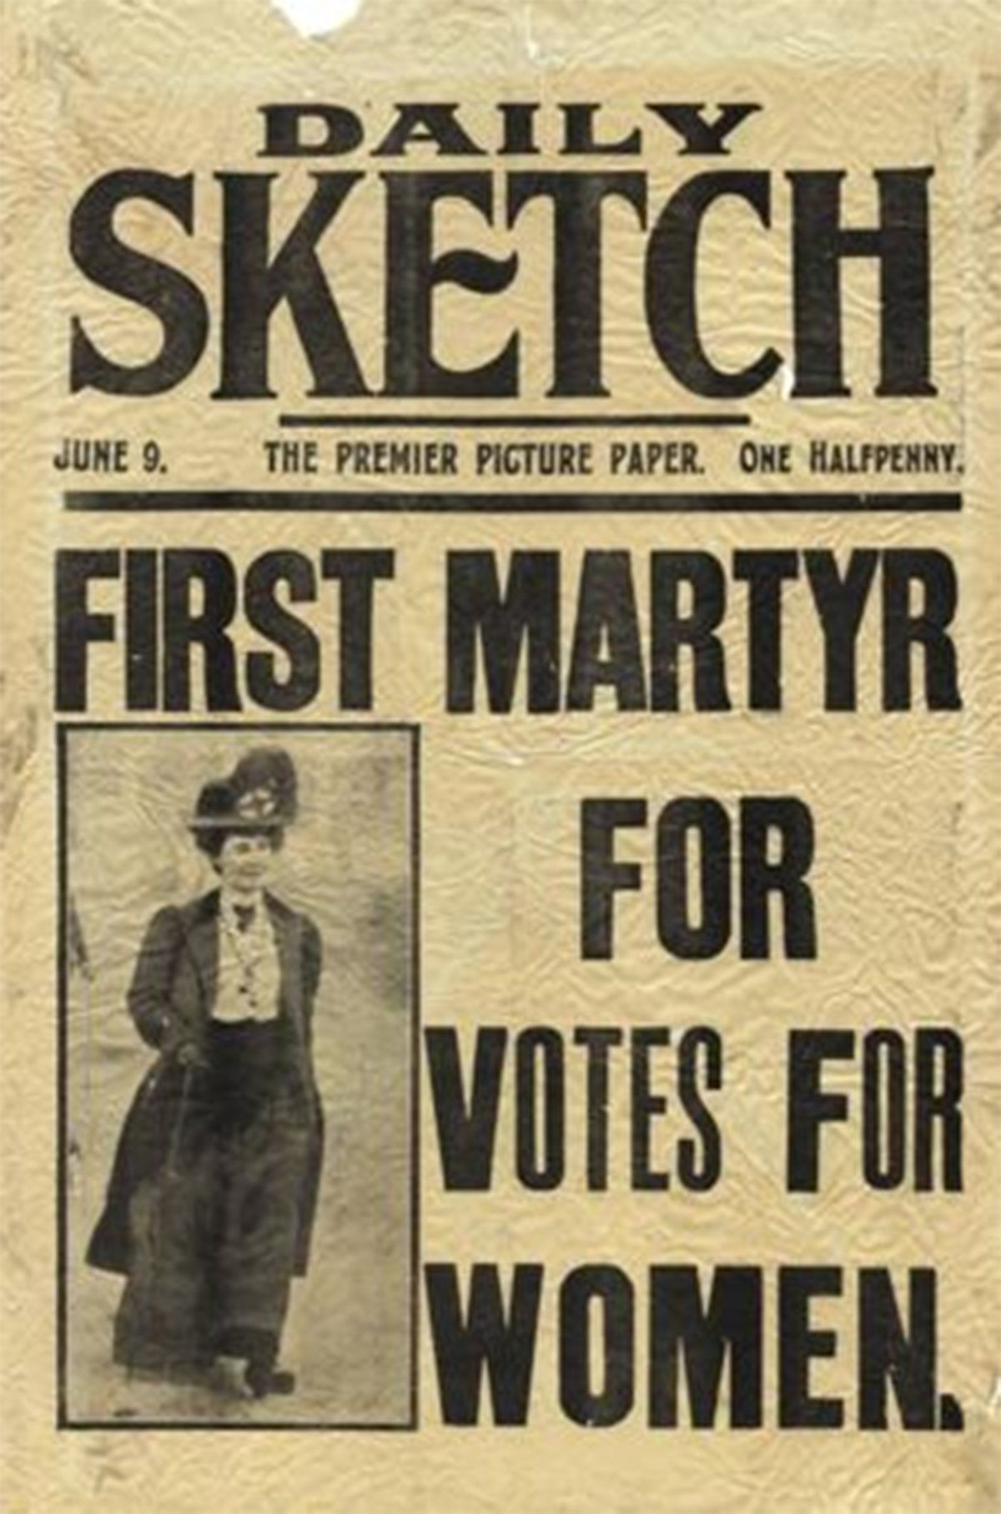

Royal Holloway Chamber Orchestra
Chapel Choir of Royal Holloway
London Mozart Players
Rebecca Miller conductor
Rupert Gough conductor

Vaughan Williams Serenade to Music (1938)
Beethoven Symphony No. 5 in C minor, Op. 67
Joanna Marsh Pearl of Freedom

To celebrate the 100th anniversary of the Representation of the People Act, in which women first gained the right to vote, Royal Holloway, University of London has commissioned a new work from Joanna Marsh, which will be premiered by the choir and orchestra of Royal Holloway and the London Mozart Players on 31 January at St John’s Smith Square. Pearl of Freedom is a cantata choral in eight episodes with a text written by David Pountney (librettist and artistic director of Welsh National Opera). This work is a choral retelling of the story of Emily Davison, who famously threw herself under the king’s horse at the Epsom Derby in 1913 in protestation of the treatment of suffragettes.

“The true suffragette is a warrior, the perfect Amazon, who will sacrifice everything in order to win the Pearl of Freedom for her sex: the Vote!”

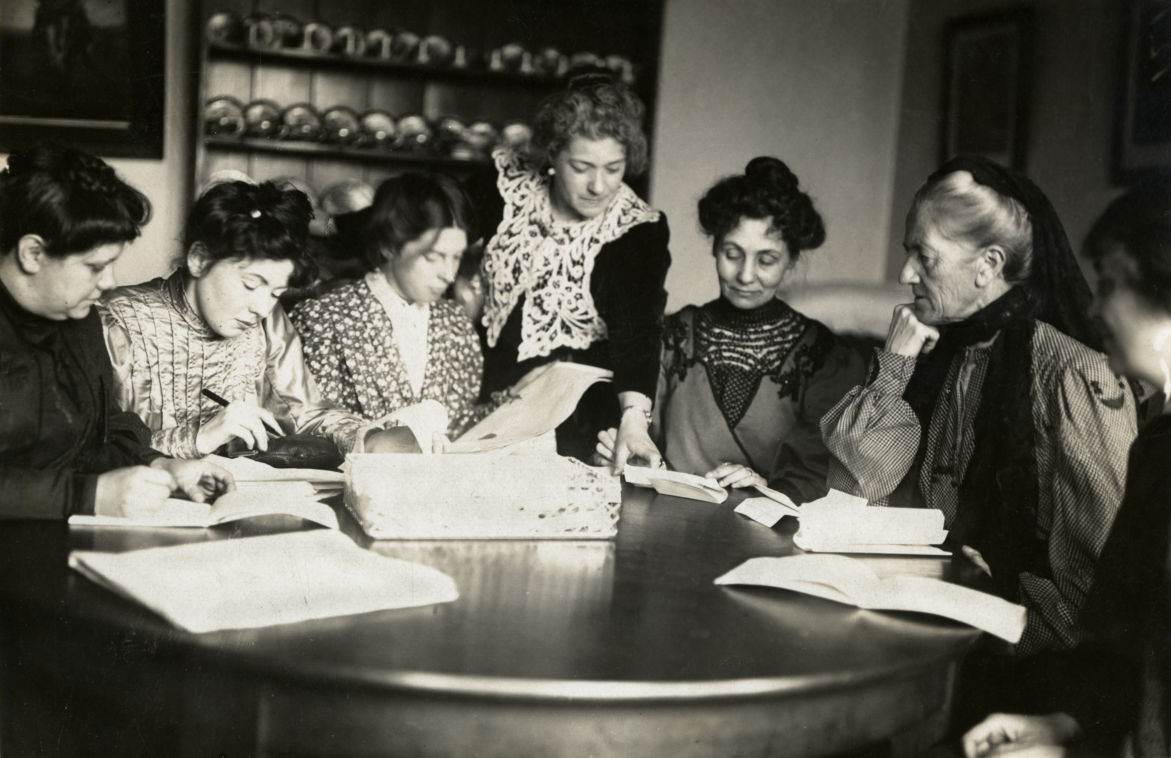
Emily Wilding Davison (1872-1913) was a militant suffragette who studied at Royal Holloway College and Oxford University, although women were still not allowed to graduate and earn a degree at this time. After briefly working as a governess she joined the Women’s Social and Political Union, which was founded by Emmeline Pankhurst and was a leading organisation in the campaign for women’s suffrage.

From 1906 she was frequently arrested for causing public disturbance, and in 1909 was sentenced to a month’s hard labour. She died after being knocked down by King George V’s horse at the 1913 Epsom Derby. Around 50, 000 people attended her funeral procession. Although her exact motive for walking onto the track is unclear multiple theories have been suggested, including an attempt to attach a suffragette banner to the king’s horse, but none have ever been proven.

David Pountney’s text records the events which led up to the Epsom Derby on 1913, the collision itself, and the aftermath.

The cantata opens with words from Emily Davison’s diary, explaining her passion for women’s suffrage. The title ‘Pearl of Freedom’ is drawn from her personal writings here, and refers to the social freedom which the vote represented.

The text juxtaposes factual elements that portray the scene (the horses names, the riders, their numbers, their colours) with Emily Davison’s state of mind. Each of these elements of the story has their own musical material, which then collides at the point of the crash. The race commentary devised by Pountney carries the music into the drama of the crash between Emily and the horse, where they both dramatically tumble and fall.

David Pountney says himself of the race commentary:

"The race commentary, in the style of Peter Bromley (I hope) has been invented because of course no such live commentaries existed at this period, but it accurately reflects the passage of the race up to Tattenham Corner where Ms Davison intervened”.

The text in the aftermath is compiled from the press of the day, a diary entry by Queen Mary, and comments from the King himself. A list of the recovered contents from Davison's handbag allows us a further musical exploration of her thoughts and beliefs. The final episode of the piece is devoted to Davison's large-scale funeral procession, which is centred on a funeral march theme and uses musical quotations from hymns sung at the funeral.

This concert is in collaboration with Royal Holloway, University of London, which has a tradition for musical excellence spanning over 100 years and, in keeping with Pearl of Freedom’s themes, was one of the first universities to admit women. Fittingly, Emily Davison was briefly a student at Royal Holloway.

Joanna Marsh
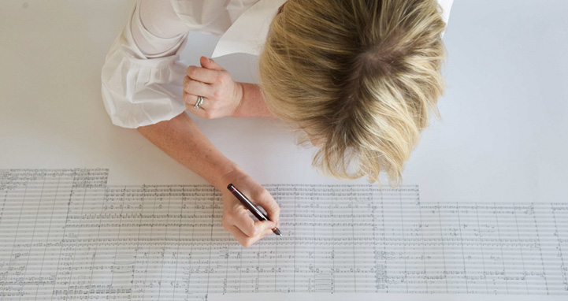
Joanna Marsh is a British composer who has been living in Dubai since 2007. She is the current Composer in Residence, at Sidney Sussex College, Cambridge and is also Co-Founder and Artistic Director of ChoirFest Middle East in Dubai, an annual celebration of the region’s choral music scene.
Most recently she was commissioned by Dubai Opera to write an orchestral work for the first BBC Proms in Dubai in March 2017. This lead to her writing the 6 minute work Flare, for the BBC Symphony Orchestra, based on a short story called Oil Field, by Saudi writer Mohammed Hasan Alwan.
Many of her other orchestral works were initiated in Dubai. Kahayla was commissioned by an international book company who wanted a composition to feature in a book celebrating the building of the Burj Khalifa. In response Joanna wrote a piece for large symphony orchestra, with its score hand written to form a giant drawing of the Burj Khalifa.
The state visit of HM Queen Elizabeth to Abu Dhabi in 2010 lead to the commissioning of her fanfare, “The Falcon and the Lion” by the British Embassy in Dubai. Following this a number of works were commissioned both for brass ensemble and for harp duo by the Emirates International Festival of Literature.
Joanna’s recent opera “My Beautiful Camel”, a romping comedy, was composed with librettist David Pountney and pulls in many cultural themes from the Emirate. The story is derived from her personal experience of working in the UAE.
As a part of her residency at Sidney Sussex, Joanna is writing a series of choral works which will be recorded by the choir in 2018. She is also bringing to choir to Dubai and Jordan in 2017 to perform with local musicians and hopes to deepen artistic ties between the countries.
Joanna (b. 1970) studied at the Royal Academy of Music in London and was an organ scholar at Sidney Sussex College Cambridge. She studied composition with Richard Blackford and Judith Bingham.

The Choir and Orchestra of Royal Holloway, University of London

Royal Holloway, University of London, has a tradition of inspiring musical excellence spanning over 100 years. Founded as a ladies college, at a time when few universities admitted women, the campus community in Surrey is home to one of the world’s top university music departments.

The Choir of Royal Holloway is considered to be one of the UK’s finest mixed-voice collegiate choirs. The 24 choral scholars undertake a busy schedule under the supervision of Director of Choral Music, Rupert Gough.

The Royal Holloway Chamber Orchestra includes scholars from the College’s orchestral scholarship programme. They are conducted by Director of Orchestras, Rebecca Miller, and participate in a unique side-by-side performance scheme with the UK’s oldest chamber orchestra, The London Mozart Players.

Following their 2017 debut performance together at St John’s Smith Square, these ensembles unite with the London Mozart Players for a showcase including Beethoven’s masterpiece 5th Symphony and Vaughan Williams’ Serenade to Music.

For more information please contact:
Nicky Thomas Media
+44 (0) 203 714 7594 | +44 (0) 207 258 0909
info@nickythomasmedia.com
www.nickythomasmedia.com

