The Monteverdi Choir and Orchestras announce an international tour of Claudio Monteverdi’s surviving operas to mark his 450th anniversary in 2017

Touring from April to October 2017 to the UK, Germany, Austria, Switzerland, France, Spain, Italy and USA

On 30 April at the Accademia Monteverdiana in Venice’s beautiful Fondazione Giorgio Cini, the Monteverdi Choir and Orchestras with Sir John Eliot Gardiner announced their plans for Monteverdi’s 450th anniversary in 2017. From 10 April to October 2017, they will embark on a global tour with a trilogy of Monteverdi’s three surviving operas L’Orfeo, Il ritorno d’Ulisse in patria and L’incoronazione di Poppea in concert performances. The trilogy provides the first opportunity for Gardiner to perform Il ritorno d’Ulisse, which will open the anniversary celebrations in Aix-En-Provence on 10 April. A highlight of the tour will be the complete trilogy in Venice at La Fenice from 16 to 21 June. With appearances at the Berliner Festspiele and Lucerne Festival, the tour continues for further dates in the UK, Austria, France, Spain, and the USA, with more festival performances to be announced in due course.

The following singers, many of whom took part at the week-long Accademia Monteverdiana in Venice, will join the tour in 2017:
Krystian Adam, Hana Blažíková, Francesca Boncompagni, Gianluca Buratto, Robert Burt, Michal Czerniawski, Peter Davoren, Yulia van Doren, Anna Denis, Francisco Fernandez-Rueda, Silvia Frigato, Kangmin Justin Kim, Lucile Richardot, Gareth Treseder (former Monteverdi apprentice), Carlo Vistoli, John Taylor Ward, Zachary Wilder and Furio Zanasi

2017 will be an important milestone in Western cultural history – one that marks the birth of Claudio Monteverdi, one of the founders of opera, who transformed the miniature form of the madrigal into a full-scale music drama. Sir John Eliot Gardiner who formed his Monteverdi Choir more than 50 years ago with a performance of the Venetian composer’s Vespers, is dedicating a year to the vision 16th century composer. In addition to the operas, the Monteverdi Choir & Orchestras will be performing the Vespers at Basilica dei Frari, Venice, as well as working alongside distinguished musicologists and experts in Monteverdi both during the Accademia Monteverdiana and the anniversary year.

As an observer of human nature in all its forms, Monteverdi presents the full spectrum of character traits from the purest to the most depraved, obsessed and corrupt. Monteverdi’s operas invite direct comparison with the greatest artists and scientists of his age – Shakespeare, Galileo, Caravaggio, Rubens, Titian and Tintoretto. Above all, it is Monteverdi’s talent for communicating emotion through music that is the driving force of his operas, which have not lost their power through the centuries.

Starting in the realm of the demigods, charismatic musician Orpheus descends to the underworld in an attempt to bring his beloved Eurydice back to life. His journey proves fruitless, as he cannot prevent himself from looking back at Eurydice as she follows him back to the living world and he loses her forever to the world of the dead.

From the pastoral world of Orpheus, Monteverdi moves to the Homeric world of Odysseus in the aftermath of the Trojan War. When Ulysses, King of Ithaca, returns home at the end of a ten-year journey he finds his faithful queen, Penelope, besieged by a trio of unctuous suitors and urged by her advisors to accept a new husband. Ulysses (with both the help and hindrance of the quarrelling gods) eventually convinces her of his true identity, routs the three suitors and regains his kingdom.

Monteverdi’s final opera is a celebration of carnal love and ambition triumphing at the expense of reason and morality. Set in a world of shifting alliances, formed and dissolved in the attempt to achieve amorous goals and social ambitions, the opera focuses on anti-heroine Poppea’s ruthless rise from Nero’s mistress to his acknowledged queen. In an opera of stark contrasts, Monteverdi prepares us to despise Nero and Poppea as they are satirised by two disgruntled sentry guards, and yet the ensuing portrayal of the two lovers as they exchange and entwine musical lines leaves us under their irresistible spell.

As Gardiner explains:
“The full unchanging gamut of human emotions - bewildering, passionate, uncomfortable and sometimes uncontrollable - form the subtext of all of Monteverdi's surviving musical dramas. More often than not, he shows a deep empathy for his characters - including the less salubrious ones - just as his contemporary Shakespeare does. Both revelled in juxtaposing tragedy with lowlife comedy. Both men lived on the cusp of exciting, and dangerous, cultural worlds. By performing the trilogy in consecutive performances we hope to take audiences on a voyage – from the pastoral world to the court and the city, from myth to political history, from innocence to corruption, from a portrait of man subject to the whim of the gods, to a hero imprisoned by his human condition, and finally to a dual portrait of mad lovers, uncontrolled in their ambition and lust. Who is the true victor in the end? Perhaps the music.”

Several academics will be taking part in the Monteverdi 450th anniversary project, their journey having started in Venice in April. This includes the following participants:

Rodolfo Baroncini (Conservatorio di Adria), Lorenzo Bianconi (University of Bologna), Tim Carter (University of North Carolina), Davide Daolmi (University of Milan), Paolo Fabbri (University of Ferrara), Iain Fenlon (King’s College Cambridge), Carlo Lanfossi (University of Pennsylvania)
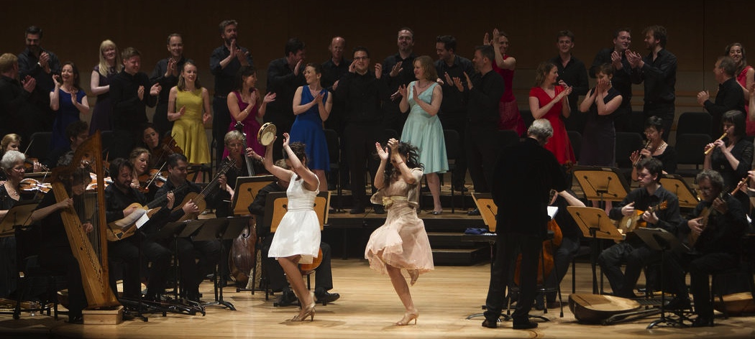

L I S T I N G S 2 0 1 7

April
10 AIX-EN-PROVENCE – Grand Theatre ULISSE
12 BRISTOL – Colston Hall ULISSE

May
3 BARCELONA - Palau de la Musica POPPEA
8 BRISTOL – Colston Hall POPPEA
31 BRISTOL – Colston Hall ORFEO

June
16 VENICE – La Fenice ORFEO
17 VENICE – La Fenice ORFEO
18 VENICE – La Fenice ORFEO
20 VENICE – La Fenice ULISSE
21 VENICE – La Fenice POPPEA

August
23 LUCERNE FESTIVAL ORFEO
25 LUCERNE FESTIVAL ULISSE
26 LUCERNE FESTIVAL POPPEA

September
2 BERLIN FESTSPIELE – Philharmonie ORFEO
3 BERLIN FESTSPIELE – Philharmonie ULISSE
5 BERLIN FESTSPIELE – Philharmonie POPPEA
16 PARIS – Philharmonie ORFEO
17 PARIS – Philharmonie ULISSE
18 PARIS – Philharmonie POPPEA

October
12 to 21 October USA
Tour of the full trilogy in the USA to be announced

Further dates for the full trilogy in Austria and the UK to be announced

ORFEO
CAST INCLUDES:
Krystian Adam (Orfeo), Yulia van Doren (La Musica/Euridice), Hana Blažíková (La Musica/Euridice), Lucile Richardot (Messaggera), Anna Dennis (Ninfa), Kangmin Justin Kim (Speranza), Francisco Fernandez Rueda (Pastore I), Gareth Traseder (Pastore II/Spirito II/Echo), Michal Czerniawski (Pastore III), Gianluca Buratto (Caronte/Plutone), Francesca Boncompagni (Proserpina), Peter Davoren (Spirito I), Furio Zanasi (Apollo)

ULISSE
CAST INCLUDES:
Furio Zanasi (Ulisse), Lucille Richardot (Penelope), Yulia van Doren (Minerva/Fortuna), Hana Blažíková (Minerva/Fortuna), Krystian Adam (Telemaco), Francisco Fernandez Rueda (Eumete), Robert Burt (Iro), Zachary Wilder (Eurimaco), Anna Dennis (Melanto), John Taylor Ward (Tempo/Giove), Francesca Boncompagni (Giunone), Silvia Frigato (Amore), Carlo Vistoli (Umana fragilità), Gianluca Buratto (Nettuno), Gianluca Buratto (Nettuno/Antinoo), Michal Czerniawski (Pisandro), Gareth Treseder (Anfinomo)

POPPEA
CAST INCLUDES:
Yulia van Doren (Poppea/Drusilla/Virtù), Hana Blažíková (Poppea/Drusilla/
Virtù), Kangmin Justin Kim (Nerone), Carlo Vistoli (Ottone), Gianluca Buratto (Seneca), Lucile Richardot (Arnalta), Michal Czerniawski (Nutrice), Silvia Frigato (Amore/Valletto), Anna Dennis (Fortuna), John Taylor Ward (Mercurio/Littore), Furio Zanasi (Soldato I/Soldato II/Liberto), Zachary Wilder (Lucano), Francesca Boncompagni (Damigella), Lucile Richardot (Venere)

All cast listings are subject to change.

Monteverdi Choir & Orchestras
Founder Sir John Eliot Gardiner

For the past half a century, the Monteverdi Choir, English Baroque Soloists and Orchestre Révolutionnaire and Romantique have set new standards, shaped opinions and breathed fresh energy into both forgotten and established repertoire. Their founder and conductor John Eliot Gardiner has devoted more than 50 years to the study of period instrument performance practice from the baroque to romantic repertoire.

The Monteverdi Choir was established in 1964 for a groundbreaking performance of Monteverdi’s Vespers at King’s College Chapel, Cambridge. Ever since the Monteverdi Choir has proven to be a powerhouse for young choral singers as many former members have moved on to successful solo careers. Memorable was also their recorded live performance of Monteverdi’s Vespers at St. Mark’s Basilica in Venice in 1989 marking the choir’s silver anniversary. For their 50th anniversary in 2014, the Choir went back to King’s College to revive their first concert in a live broadcast on BBC Radio 3.

The English Baroque Soloists were founded in 1978 and have - together with John Eliot Gardiner - always sought to challenge preconceptions of Baroque and early Classical music. Combining the untamed sound of period instruments, with passionate and virtuosic playing, they have set the benchmark for period instrument performance that has shaped performance practice for the last three decades. Their current leader is Kati Debretzeni.

A towering achievement for the Monteverdi Choir and English Baroque Soloists was marking Bach's 250th anniversary in 2000 by performing and recording all 198 of JS Bach’s sacred cantatas on the appropriate feast day in more than 60 churches across Europe. Subsequently the Monteverdi Choir & Orchestras set up the company’s record label, Soli Deo Gloria, to release the entire cycle which was hailed as “one of the most ambitious musical projects of all time” by Gramophone magazine. In 2014, Sir John Eliot Gardiner brought out a new biography on Bach entitled “Music in the Castle of Heaven”.

All three ensembles have also been a fertile training ground for generations of performers who have gone on to shine internationally. In 2007, the Monteverdi Apprenticeship Programme was established to further develop future generations. The Choir and English Baroque Soloists have over 150 recordings to their name and have won numerous prizes. The Financial Times described their most recent album together, Bach’s B Minor Mass, as "Bach at its most glorious and uplifting".

Sir John Eliot Gardiner was appointed President of the Bach Archive in Leipzig in 2014 and has recently received the Concertgebouw Award in Amsterdam.

http://www.monteverdi.co.uk

Twitter: @mco_london
The Monteverdi Choir and English Baroque Soloists are under the grateful patronage of HRH the Prince of Wales.

For further information, please contact:

Nicky Thomas Media
International media relations for the Monteverdi Choir & Orchestras
+44 20 7258 0909 or +44 20 3714 7594
info@nickythomasmedia.com | www.nickythomasmedia.com
Twitter: @ntmediauk

