Brazilian pianist Clélia Iruzun launches CD Ernesto Nazareth:
Portrait of Rio on the LORELT label

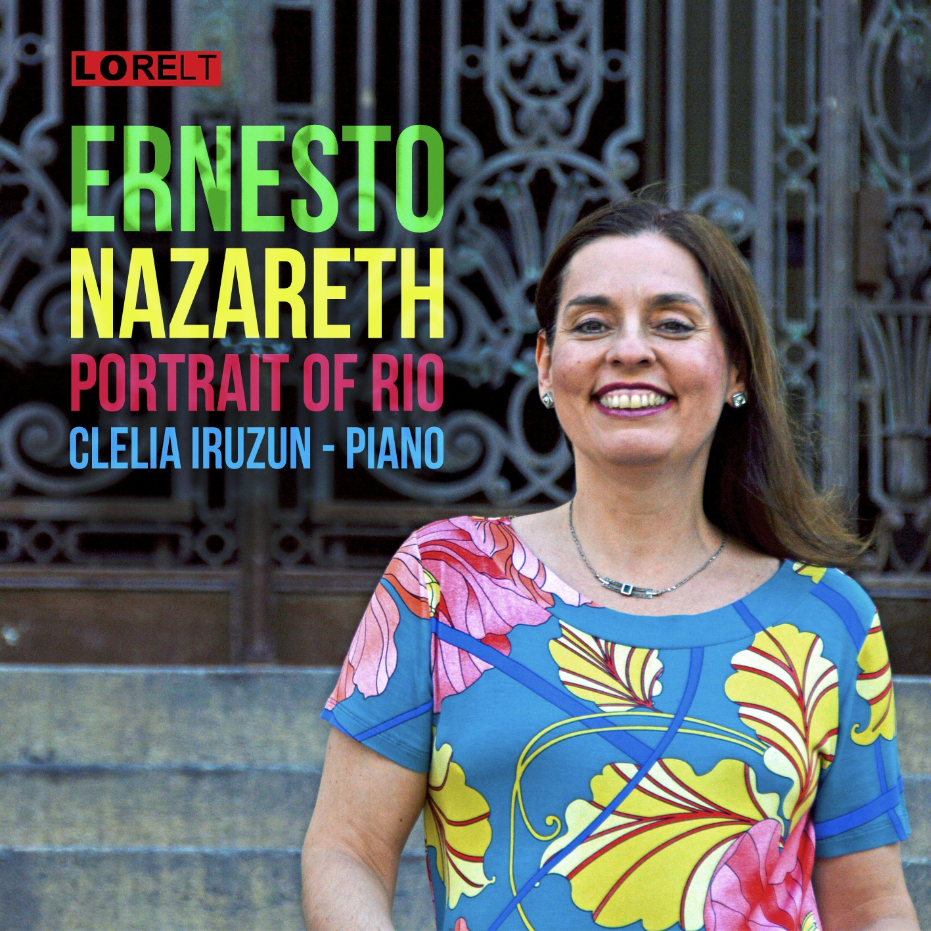
‘Ernesto Nazareth’
CD no. LNT139
Clélia Iruzun pianist
Release date 20 May 2015
Label LORELT Ltd.

CD Launch Recital
St James Studio, SW1E 5JA
20 May 2015 at 8pm
Buy tickets here
Nazareth | Chopin | Gottschalk
Full programme below

‘The result is a fine legacy, beautifully showcased here by Iruzun’
Gramophone

Watch Clélia's new video on Ernesto Nazareth and his music here:
https://www.youtube.com/watch?v=Scpi-xMQjbg

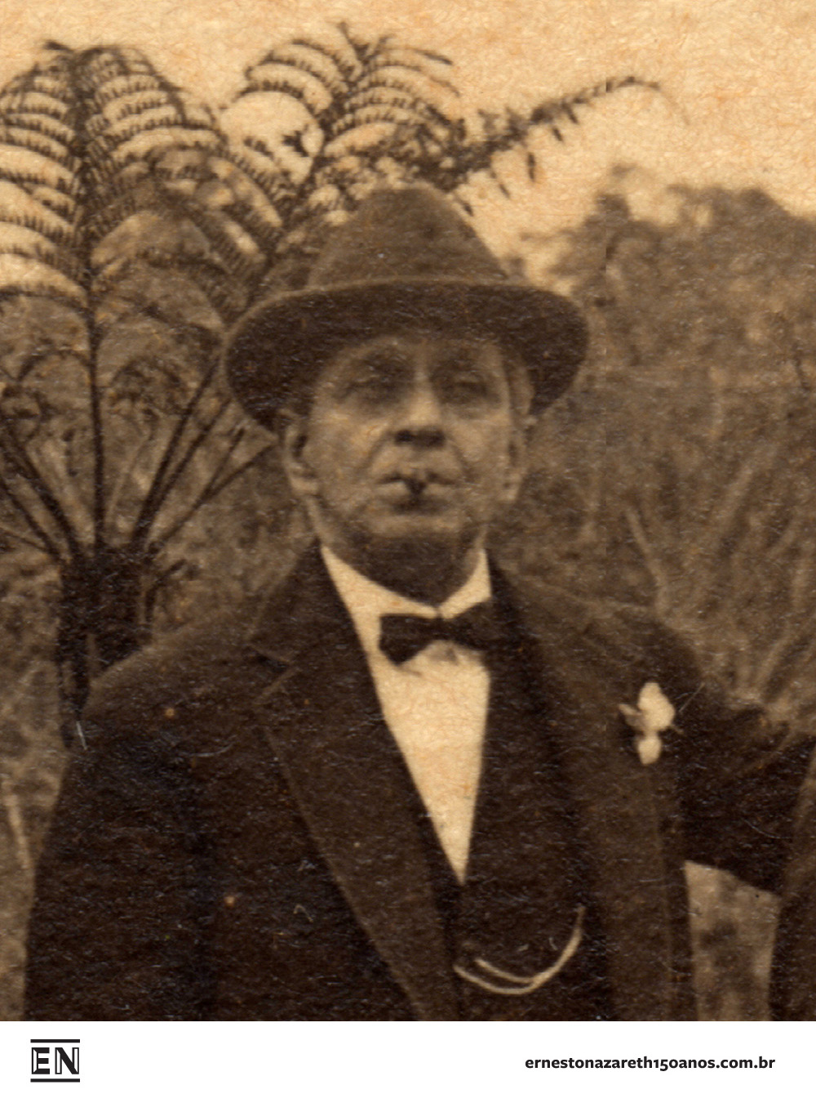
Brazilian pianist Clélia Iruzun releases her latest disc of solo piano music by Afro-Brazilian composer Ernesto Nazareth at a recital at St James Studio on 20 May 2015. Her recital programme places the music of Ernesto Nazareth alongside his inspirations - Chopin and Gottschalk. Though extremely popular in Brazil since the turn of the 20th Century, Ernesto Nazareth’s music is little known and appreciated in Europe. Iruzun’s new disc is a collection of tangos, polkas and waltzes, merging some of Nazareth’s better-known works alongside debut recordings of Recordações do Passado, Marietta and Marcha Fúnebre.

As Clélia Iruzun explains:

"Nazareth’s piano music has been part of my life since childhood. He is a unique figure in Brazilian music as he belongs both to classical and popular musical genres. He was carioca (native of Rio) like myself and his music is the essence of our city with its urban sophisticated character, full of wit and charm. One could say that his music is like a Brazilian Scott Joplin. This CD is a homage to Rio as it celebrates 450 years and I hope that it will inspire a re-evaluation of Nazareth’s unique music."

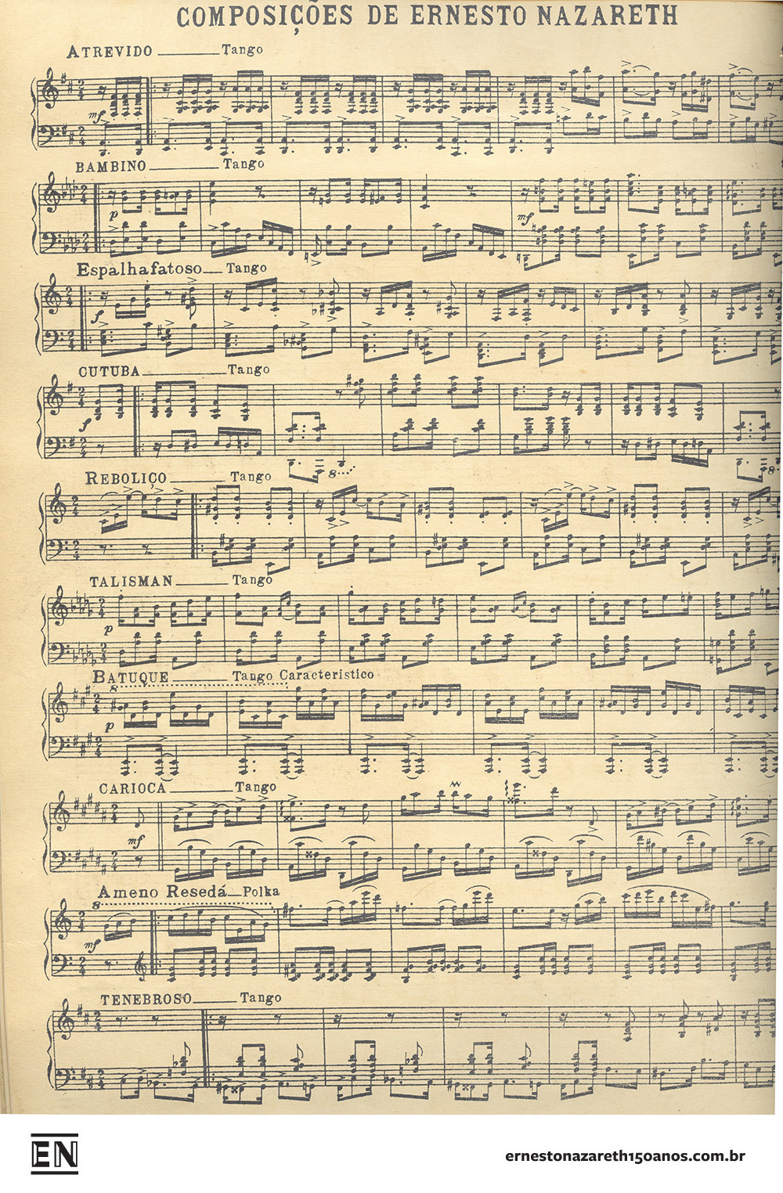
Ernesto Nazareth (1863 – 1934) was brought up in a modest family in Rio and his mother taught him the piano from a young age, until she died when he was ten years old. He was then taught by Eduardo Madeira and Lucien Lambert who introduced him to the music of Chopin. He became a regular fixture at the Odeon cinema, performing before the main feature and became such a draw that audiences came to hear him and left before the film. At this time, great musicians and composers such as Darius Milhaud, Heitor Villa Lobos and Arthur Rubinstein heard Nazareth performing there. Darius Milhaud used some of Nazareth’s themes in his own pieces, most notably the ballet Le Boeuf Sur le Toit.

Nazareth’s compositions number some 211 complete works, including 88 tangos, 41 waltzes, 28 polkas and numerous sambas, gallops, fox-trots and others. Nazareth’s music was hugely influenced by Chopin’s dance inspired piano works. A notable similarity can be seen between Chopin’s Waltz Op. 34 No. 1 and Nazareth’s Fantástica - both of which Iruzun will play at the launch. He often dedicated his compositions to his family, for example the polka Marietta for his daughter Maria and the tango Escovado to his brother Fernando which is a tongue-in-cheek depiction of a smart debonnaire young man, an ironic parody.

Though he never became wealthy, his music was immensely popular, often transcribed for larger ensembles and popular bands in the cafes and bars of Rio. Walt Disney used Nazareth’s Apanhei-te Cavaquinho for a cartoon with Donald Duck and Dengoso was used by Hollywood – probably without Nazareth’s knowledge - in the film The Story of Vernon and Irene Castle with Fred Astaire and Ginger Rogers.

Programme for St James Studio recital:

Nazareth: Escovado, Fantastica, Ameno Reseda, Suculento, Carioca, Polonesa
Chopin: Waltzes Op. 34 No. 1 and Op.18, Polonaise Op.26 No.1
Gottschalk: Union Paraphrase on National Airs

“Colours, strong rhythms and fire characterise the performances by Clélia Iruzun”

Tribuna Da Imprensa

CD track listings:

- Escovado – Tango (1904)
- Ameno Resedá – Polca (1913)
- Fantástica - Valsa Brilhante (1922)
- Suculento - Samba brasileiro (1919)
- Plangente - Tango em estilo habanera (1925)
- If I am not mistaken - Fox-trot (1920)
- Cacique – Tango (1899)
- Carioca – Tango (1913)
- Polonesa – Polonaise (1907)
- Pássaros em Festa – Valsa (1920)
- Dengoso – Maxixe (1907)
- Batuque - Tango Característico (1913)
- Marcha Fúnebre (1926)
- Ouro sobre Azul - Tango (1915)
- Êxtase – Romance (1907)
- Marietta – Polca (1894)
- Digo – Tango (1900)
- Recordações do Passado – Valsa (1885)

Clélia Iruzun

With her combination of colourful Brazilian spirit and musicianship, London-based pianist Clélia Iruzun is one of the most exciting musicians to emerge onto the international scene in recent years.

Clélia’s childhood was spent in the rich cultural atmosphere of Rio de Janeiro where she began playing the piano at the age of four, winning her first competition at seven and making her orchestral debut playing Grieg’s Piano Concerto at 15. At 17 Clelia won a scholarship to continue her development by studying with the highly regarded Maria Curcio in London, and then with Christopher Elton, who took her under his wing at the Royal Academy of Music where she graduated with the Recital Diploma. Later she also studied with Noretta Conci and then with Mercês de Silva Telles, who encouraged Clélia to develop her own definitive style. Her mentors have included Fou Ts’Ong, Stephen Kovacevich, and her compatriots, the great pianists Jacques Klein and Nelson Freire. Even from the early years of her career, Clélia’s stunning piano playing caught the attention of prominent musical figures such as Francisco Mignone who wrote a Suite especially for her and more recently Marlos Nobre who also dedicated a piece for her. Clélia has won many awards in Brazil and in Europe, such as the Tunbridge Wells Piano Competition in the UK, the Paloma O'Shea in Santander and Pilar Bayona in Zaragoza, Spain.
Clélia Iruzun has given recitals and concerto performance all over Europe, the Americas and Asia. Her tours in China included concerts for huge audiences, including recitals at the Grand Theatre in Shanghai, Hangzhou, Ningbo and the Forbidden City Concert Hall in Beijing. Her recital in Shanghai was voted one of the ten best concerts of the year. She has also toured China and Brazil with the Coull Quartet and performed with them again in the UK in the Southbank and in their series in Warwick University.

In the UK she has performed at the Wigmore Hall, the Purcell Room and Queen Elizabeth Hall, St John’s Smith Square and music societies and festivals across the country. She has also appeared several times on radio and television, including broadcasts for BBC Radio 3.
Concert tours have taken her across Canada and the USA, to Yugoslavia, Poland and the Czech Republic, Portugal, France and Spain. She has performed extensively in Scandinavia as well.

In her native Brazil she is a regular performer on TV and radio and major concert halls where she has also premiered works by British composers such as York Bowen and Arnold Bax; recent performances include the prestigious Campos do Jordão Festival and concertos with the leading orchestras in the country.

Clelia has recently finished a Master degree in Philosophy at the Birkbeck College, University of London.
www.cleliairuzun.com

Ernesto Nazareth
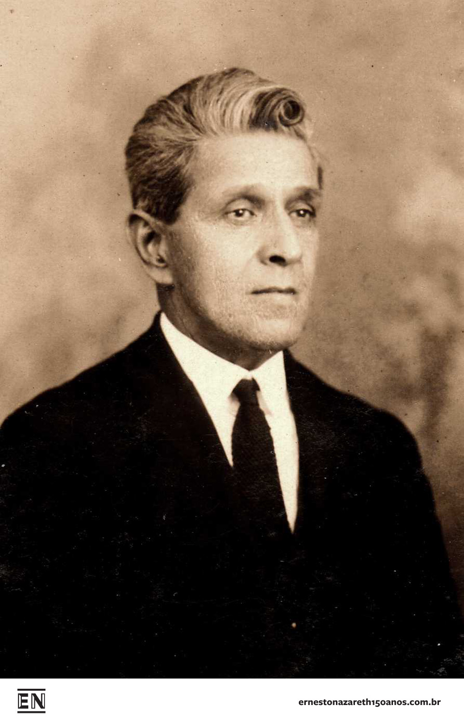
Ernesto Júlio Nazareth was the most popular composer of Brazilian national music. He had a profound influence on the course of future Brazilian music, both popular and classical. Fellow countryman Heitor Villa-Lobos called him "the truest incarnation of the Brazilian musical soul."
He was born into a modest family in the Morro do Nheco (later Cidade Nova) district of Rio. His father, Vasco Lourenço da Silva Nazareth, was a customs official. His mother, Dona Carolina, was a pianist and gave the boy his first music lessons. She died when he was ten years old, and his father continued his education, arranging for further piano lessons from Eduardo Madiera and Lucien Lambert. They taught him good piano technique and familiarized young Ernesto with European music. He was particularly pleased with the shorter, fanciful pieces of Frédéric Chopin. It is likely that he was also influenced by the American composer Louis Moreau Gottschalk (1829-1869), who died in Rio and was one of the first to mix European and Brazilian musical elements.
At the age of 14, Ernesto wrote his first composition, the polka Você bem sabe, which was published the same year. He continued to write popular short pieces, and joined several musicians in giving a concert when he was 17 at the Club Rossini in São Cristóvão. That same year, Nazareth joined a band of chorinhos, performers of the urban variety of folk music he loved. The strolling serenaders used guitar, mandolin, flute, clarinet, and the small Portuguese guitar called the cavaquinho and had evolved the nostalgic song form called choro.
Nazareth was one of the first to blend polka and maxixe with the habanera, resulting in a new dance rhythm that Nazareth called the "Brazilian tango." It is not closely related to the more sultry Argentine tango, but is faster and more joyful. In similar fashion Nazareth added Brazilian elements to European forms, creating what he called the "Brazilian march," "Brazilian polka," "Brazilian waltz" and "Brazilian fado."
He married, and, to support his growing family (he had four children), sold the full rights to what would be one of his most popular compositions, the tango Brejeiro. He was employed by the music publisher Casa Carlos Gomes to demonstrate new publications. When silent films came along, he was one of a few musicians to provide concerts before the films were shown, on the piano and with the theater orchestras, in one of which Villa-Lobos was a cellist. He eventually came to be one of the most popular movie theater musicians, drawing crowds that came to hear him at least as much as to see the film. Another of his popular works, Odeon, is named after the most famous of these theaters.
In 1918, his daughter Maria de Lourdes died during the worldwide Spanish influenza epidemic. He began showing signs of depression, which worsened after his wife died in 1929. Despite these tragedies, he had attained national fame, and attracted large audiences in one of Brazil's largest cities, São Paulo, where his admirers presented him with a new piano. When the new radio station, Radio Sociedade, went on their air in 1930, it chose his music for its first presentation.
Then he was struck by deafness in his right ear, deepening his depression. He began to exhibit irrational behavior, and was ultimately hospitalized in the Colônia Juliano Moreira in Jacarepaguá, a forested part of Rio. On February 1, 1934, he went for a stroll. Some speculate he was attempting to escape the hospital, but, nonetheless, he got lost in the woods and was found dead three days later.

LORELT (Lontano Records Ltd.)

LORELT was founded by in 1992 to record and disperse throughout the world the work of Contemporary composers, Women composers and Latin American composers from all centuries. The label has been praised by critics and music lovers for their adventurous and outstanding work. In 2002, to celebrate its 10th Anniversary, Lorelt became the first Independent UK label to offer MP3 downloads from its website. With worldwide CD and digital distribution, Lorelt is a force to be reckoned with.
www.lorelt.co.uk

St James Theatre

St James Theatre is a unique, award winning arts complex in central London, which opened in September 2012. With a 312 seat main house presenting plays, musicals and revues, and a 120 capacity Studio in cabaret style offering over 250 shows a year, the St James has quickly established itself as the vibrant cultural hub of the rapidly developing Victoria area and a major player on the wider cultural scene. The Studio features excellent acoustics and its own integrated bar and has been described as bringing a piece of 1930s New York to London. The programme in the studio is vast and varied, incorporating the very best of both established and emerging talent in the worlds of cabaret, comedy, jazz and roots, magic, music, opera and theatre – to name but a few of the genres programmed.

www.stjamestheatre.co.uk

www.cleliairuzun.com

For more information on any of the above, please contact:
Nicky Thomas Media
+44 (0) 203 714 7594 | +44 (0) 7768 566530
info@nickythomasmedia.com
www.nickythomasmedia.com

