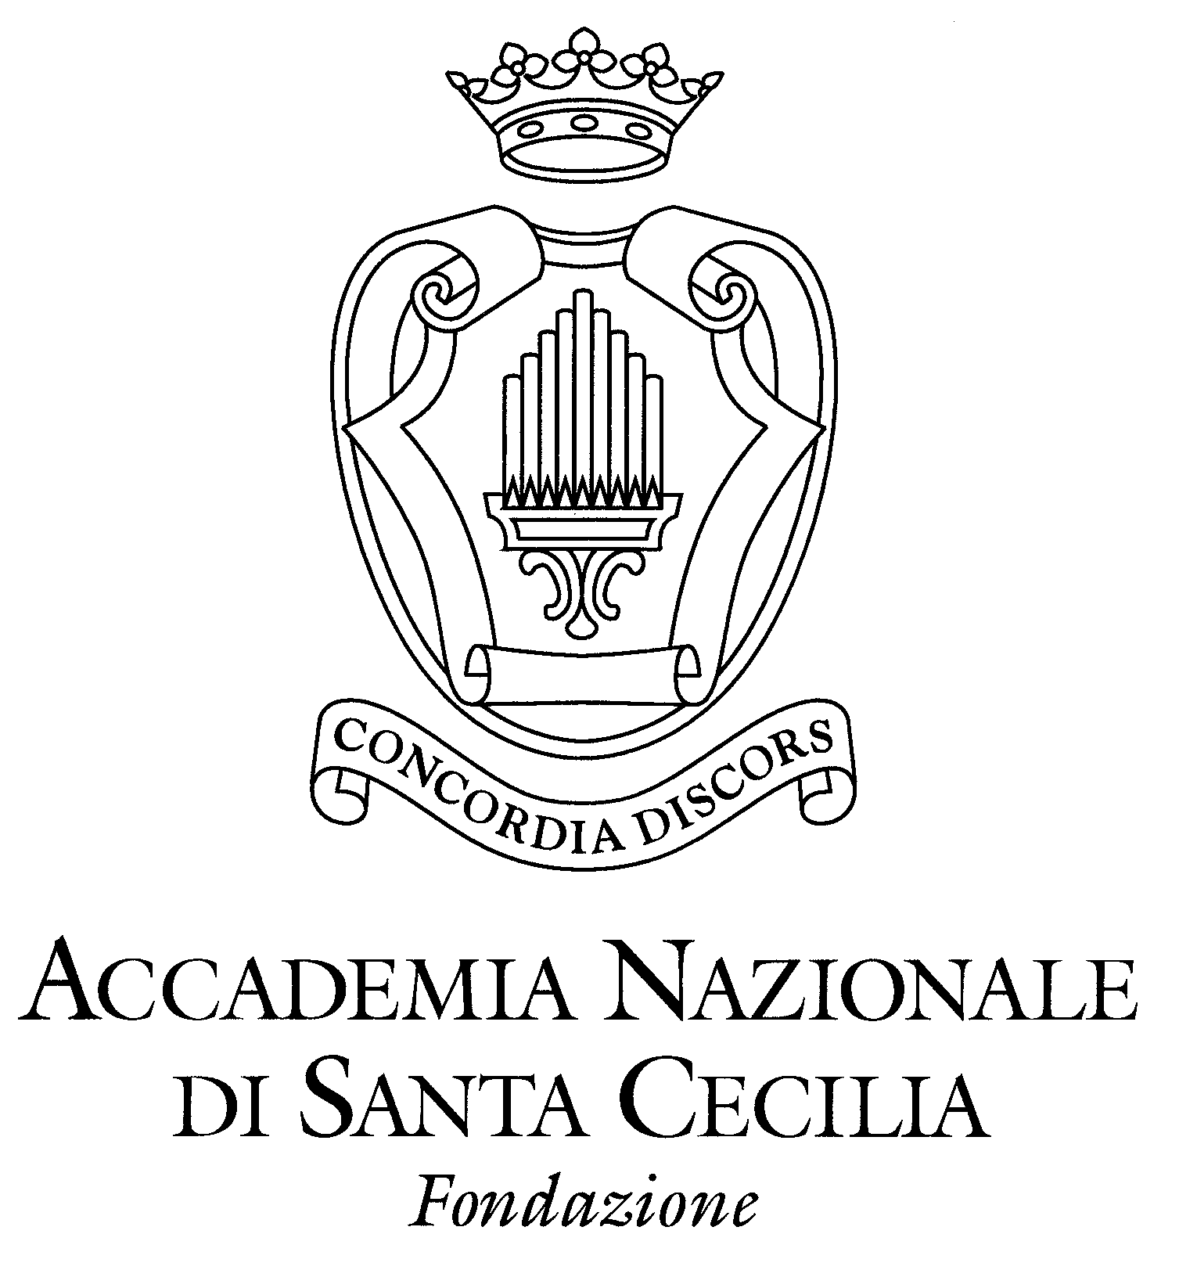

Sir Antonio Pappano and the Orchestra of the Accademia Nazionale di Santa Cecilia embark on a tour to Prague, Dresden and Vienna 28 May to 1 June 2015

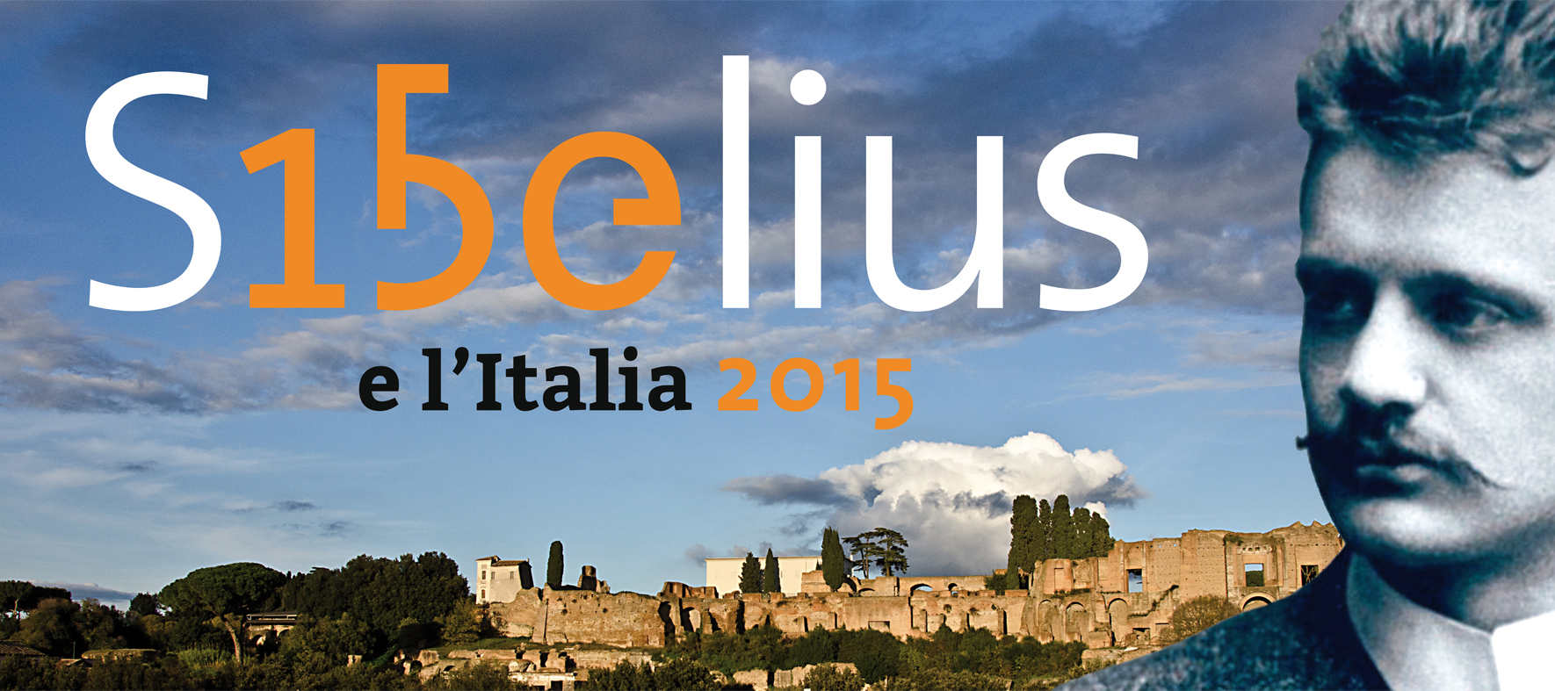
28 May 2015 - PRAGUE Smetana Hall, Prague Spring Festival
29 May 2015 - DRESDEN Semperoper
31 May 2015 - VIENNA Konzerthaus

Conductor Sir Antonio Pappano
Cello Jan Vogler

RACHMANINOFF, The Isle of the Dead
*VERDI, Overture La Forza del destino [*only in Prague]
TCHAIKOVSKY, Rococo Variations
SIBELIUS, Symphony No. 2

30 May 2015 - DRESDEN Frauenkirche
1 June 2015 - VIENNA Konzerthaus

Conductor Sir Antonio Pappano

BRUCKNER, Symphony No. 8

Sir Antonio Pappano and the Orchestra of the Accademia Nazionale di Santa Cecilia tour to Central Europe – Prague, Dresden and Vienna – from 28 May to 1 June. Making their debut at the Prague Spring Festival, Pappano and his award-winning Roman orchestra mark the 150th anniversary of Sibelius [1865-2015] with a programme of the composer’s Symphony No.2 alongside Verdi, Rachmaninov and the Tchaikovsky Rococo Variations with young Czech cellist Jan Vogler. The tour continues to Dresden with the same programme plus a secondary one of Bruckner’s epic Symphony No. 8 in the remarkably reconstructed Frauenkirche, followed by further concerts at the Vienna Konzerthaus. Previous conductors who conducted the Accademia di Santa Cecilia in performances of Bruckner No. 8 in Rome have included Carlo Maria Giulini, Georges Prêtre and Zubin Mehta. Immediately prior to the tour, there will be performances of Bruckner 8 in Rome on 23,25,26 May.

Sibelius was a great admirer of Italy, travelling extensively across the country and after the first concert of his music in Bologna conducted by Arturo Toscanini, his compositions continued to be performed frequently in Italy. In 1916, Sibelius was nominated an Honorary Academician of Santa Cecilia and in 1923, he conducted the Roman orchestra at its former home at the Augusteo. The programme included Pelleas, the Return of Lemminkainen and the 2nd Symphony, which Sibelius had started in Rapallo on the Ligurian coastline on an earlier trip to Italy and later completed in his Finnish homeland. Throughout 2015, the Accademia di Santa Cecilia will be marking the composer’s 150th anniversary, with a series of events - concerts, exhibition “The World of Jean Sibelius” in its Museum of Musical Instruments and a conference to retrace Sibelius’ musical journey across Italy.

2014/15 Season in Rome and on tour

The 2014/15 Season sees Pappano travel with his Roman Orchestra to 24 cities across the Far East and Europe, as well as presenting a rich offering in Rome of 18 concerts of orchestral, choral and operatic repertoire (out of 30 programmes presented by Santa Cecilia during the season and each performed three times). Their March tour included Baden-Baden, Frankfurt, Dusseldorf, Brussels, Essen, Luxemburg, Eindhoven and Amsterdam, which was a ringing success. The multi-award-winning Chorus of the Accademia Nazionale di Santa Cecilia also give a special concert in Turkey in May, returning to Istanbul to give a concert performance of Verdi’s Aida with the Borusan Istanbul Philharmonic Orchestra in memory of Turkish soprano Leyla Gencer.

The Accademia Nazionale di Santa Cecilia welcomes the world’s leading conductors and soloists during the 2014/15 season. This season’s remarkable line-up of conductors includes Yuri Temirkanov, Jonathan Nott, Semyon Bychkov, Peter Eötvös, Marc Albrecht, Gianandrea Noseda, Manfred Honeck, Christoph Eschehbach, Mikko Franck, Valery Gergiev and former Music Director Myung-Whun Chung. Legendary pianist Martha Argerich, a regular favourite in Rome, returns in April with Yuri Temirkanov.

In February, Warner Classics returned to Rome to record Pappano with his Roman orchestra and chorus in Verdi’s Aida with a stellar cast including Anja Harteros, Jonas Kaufmann, Ludovic Tezier and Ekaterina Semenchuk, culminating in an a live concert gala on 27 February. This rare studio recording of opera will be released in October 2015 to mark the opening of the 2015/16 season.

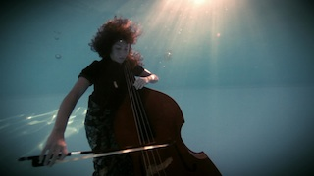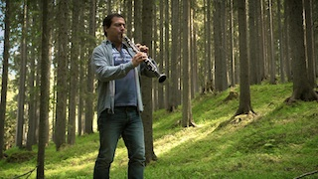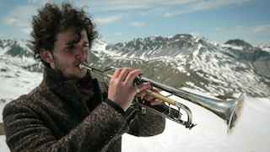

Prior and during their tour of Germany, there will be screenings of Il Carattere Italiano (The Italian Character) by Angelo Bozzolini, described by the Independent newspaper as “a masterpiece in conveying the essence of music in pictures and words”. The film gives a rare insight into this unique orchestra, going behind the scenes with its Anglo-Italian conductor and featuring guest appearances from famous artists including Valery Gergiev, Yuri Termikanov, Janine Jansen, Lisa Batiashvili, Daniel Harding, James Conlon, Evgeny Kissin and Lang Lang.

23, 25, 26 May 2015 – ROME Auditorium Parco della Musica

Orchestra of the Accademia Nazionale di Santa Cecilia
Conductor Sir Antonio Pappano
BRUCKNER, Symphony No. 8

The Orchestra and Chorus of the Accademia Nazionale di Santa Cecilia

The Accademia di Santa Cecilia is a rare example of an Italian symphony orchestra unattached to an opera house and is unanimously recognised as the country’s finest symphonic orchestra. Since taking over as Music Director nine years ago, Sir Antonio Pappano has revitalised and galvanised the Orchestra with his enthusiastic spirit, positive energy and consummate musicianship. It has been voted one of the leading orchestras of the world, whilst the Chorus of the Accademia di Santa Cecilia has been described as “one of the world’s great choirs” (The Independent), being in great demand on tour both with the Orchestra and on its own. In the UK alone, they have won more than 9 music awards over the past 2 years.

The Accademia di Santa Cecilia has an impressive heritage. Since its creation in 1908 the Orchestra has collaborated with distinguished composers including Mahler, Debussy, Richard Strauss, Sibelius, Stravinsky, Hindemith, Respighi, Berio and Stockhausen. They have also worked with conductors including Toscanini, Furtwängler, Karajan, Böhm, Kleiber, Celibidache, Sinopoli, Bernstein, Carlos Kleiber, Sawallisch, De Sabata, Stokowski, Abbado, Muti and Barenboim. Most recently its Music Directors have been Bernstein, Sinopoli, Gatti and Myung Whun Chung. They have imbued in the orchestra the great European symphonic tradition from Beethoven to Shostakovich.

Sir Antonio Pappano

Born in London, Pappano moved to the USA at the age of 13. He conducted his first performance in 1987 at the Norwegian National Opera, where he was to become Music Director in 1990. At the age of 32 he moved to Brussels, having been appointed to the same office at La Monnaie where he remained from 1992 to 2002. During this period he made his debuts in Vienna, at the Metropolitan Opera, New York, and at the Bayreuth Festival. He became Music Director of The Royal Opera in 2002 (gaining the 2003 Olivier Award for Outstanding Achievement in Opera) and of the Accademia Nazionale di Santa Cecilia in Rome in October 2005. Recent highlights with The Royal Opera include a new production of Il trittico, a celebration of Plácido Domingo's 40 years performing with The Royal Opera, a tour to Japan (conducting Manon, La Traviata and Handel's Messiah) and the world premiere of Mark-Anthony Turnage's Anna Nicole. In May 2010 he presented a widely acclaimed series, 'Opera Italia', for BBC television, and since then he has made many recordings for EMI, most recently Rossini's Guillaume Tell (released July 2011) and Mahler's Symphony no. 6 (November 2011). Pappano received a knighthood in the Queen's 2012 New Year Honours, and in May of this same year was made a Cavaliere di Gran Croce Dell'Ordine Al Merito della Repubblica Italiana.

Recent Discography

Rossini Overtures October 2014
Britten’s War Requiem, November 2013
Sacred Verdi, August 2013
Dvorak Cello Concerto and Symphony No.9, October 2012
Mahler, Symphony no. 6, November 2011
Rossini, Guillaume Tell, July 2011
Rachmaninov, Symphony no. 2, February 2011
Rossini, Stabat Mater, November 2010

Recent Awards

Antonio Pappano – Echo Klassik 2014 with Ian Bostridge
Antonio Pappano: Male Artist of the Year, Classic Brit Awards (2011)
Verismo with Jonas Kaufmann: Recital Category, Gramophone Award (2011)
Rossini Stabat Mater: Editor’s Choice, Gramophone Award (2011)

Verdi Requiem:
Critics’ Choice, Classical Brit Awards (2010)
Choral category award, BBC Music Magazine Awards (2010)
Choral award, Gramophone Awards (2010)

Madama Butterfly:
Female artist of the year (Angela Gheorghiu), Classic Brit Awards (2010)
Opera Disc Award, Classic FM Gramophone Awards

Colbran, The Muse with Joyce Di Donato:
Recital, Gramophone Awards (2010)

www.santacecilia.it

Accademia Santa Cecilia Press Office:

Largo Luciano Berio, 3, 00196 Roma
Annalisa Rinaldi, Tel. + 39 0680242330
a.rinaldi@santacecilia.it
Daniele Battaglia Tel: + 39 06 80242325
d.battaglia@santacecilia.it

For further information contact:

Nicky Thomas Media:
International media relations for Accademia di Santa Cecilia

+44 7768 566530 or +44 20 3714 7594
info@nickythomasmedia.com | www.nickythomasmedia.com
Twitter: @ntmediauk

